Goals:

1. Explain what cities can expect *after* they post a policy online
2. Identify common commenters by group (civic tech/academia/etc.)
3. Identify popular “sticking points”, i.e. things that residents care about
   1. Most popular sections, most popular comments, number of comments

Intro para:

--the benefit of doing the crowdlaw

-gap: however, it didn’t give a holistic picture of what people want - no collective information, lack of citizen engagement, equipping with tools and knowledge to address any unforseen questions/events

--why have we designed this memo? Why do you need it?

Methodology:

-policies covered

-in a brief line explain what kind of tools/techniques we have used

-In one line, provide a thesis - two to three main takeaways for the memo

Main Body (make sections descriptive):

* Level of engagement:
  + Graph: Total number of comments for each city
  + Analysis (brief)
  + Most popular sections for each city (or just main cities? Or overall?)
  + Analysis
  + Stacked Graph for each city (two bars - one for total number of likes, one for total replied to):
  + Most liked/replied to comments (sample cities - Buffalo, Syracuse, Nashville and Naperville)
  + Analysis

- Profiles of authors/commentators

- who comments the most?

- background/work

- Sentiment Analysis

- Positively Identified issues

- Neutral issues - what do they mean? Give examples of highly neutral comments

- Negative issues

**An quick-and-easy explainer for cities new to crowdlaw**

Crowdlaw for open data policy is [an approach for collaborative policy drafting](https://docs.google.com/document/d/10LKN0s9M0JhNFaAFuZzfd32cUQYcPKvaogriTzN4zgc/edit?usp=sharing) between residents and city governments. It gives residents an opportunity to provide online feedback on policies, which helps cities build better relationships with residents and get real insight into how open data will affect residents’ lives.

If you have read our [crowdlaw brief](https://docs.google.com/document/d/10LKN0s9M0JhNFaAFuZzfd32cUQYcPKvaogriTzN4zgc/edit?usp=sharing) and explored our [case study about how Pittsburgh implemented crowdlaw](https://docs.google.com/document/d/1fRWUpmqbdOFOuWF_LOHEHkOCsAGW_esVWmTYYH93Asg/edit) with Google Docs, but still have questions about what crowdlaw looks like, this explainer is for you. Over time, we have helped 41 cities use crowdlaw, and compiled a [Crowdlaw Tracker](https://docs.google.com/spreadsheets/d/10pOyaJRtKCpvNk3IZFLmVZEeNZJ4yaeaku2Ax7oL68g/edit#gid=0) to catalog their experiences. Thanks to Sunlight’s experience helping cities with crowdlaw, we’ve been able to analyze residents’ most common comments, commenters’ profiles, and the most popular policy sections that the residents have commented on in cities using crowdlaw.

For this explainer, we have individually and collectively analyzed cities that used [Madison](https://opengovfoundation.org/projects/madison-project/) to host crowdlaw activity: Buffalo, Durham, Tyler, Glendale, Nashville, Syracuse, Naperville, Bart and San Francisco. We looked at some of the most common policy sections based on number of comments made by users, characteristics such as the professional background of the users who comment, and top policy sections that received most positive or negative feedback.

**Note: We only analyzed cities that used Madison but plan to update this guide with information about the experiences of cities using Google Docs, and/or other platforms.**

**How does the the community engage with open data policies?**

***Level of engagement based on total comments***

**~~Figure 1: Total comments for each city~~**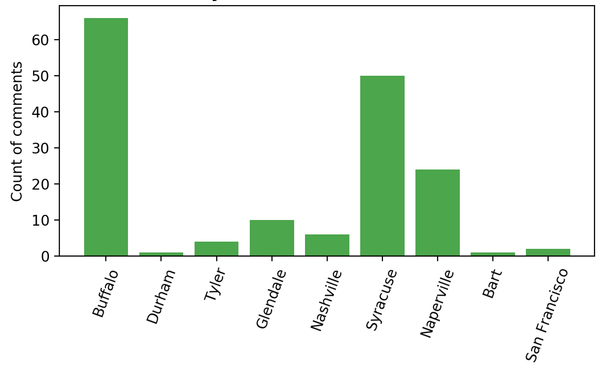

The cities of Buffalo, Syracuse, and Naperville had the highest levels of community engagement when using crowdlaw. The City of Buffalo, in particular, has had an active crowdlaw practice since the day it drafted its Open Data Policy six months ago (why?). Bart and and Durham received only one comment (why?), showing very low levels of engagement with the community.

***Most popular policy sections***

When cities understand which policy sections are most popular, it can help them anticipate how people will react to their open data policy. Cities can use this information, ahead of time, to prepare materials and answers to effectively engage with community. In our analysis, popular policy sections are those which have been quoted by different people two times or more.

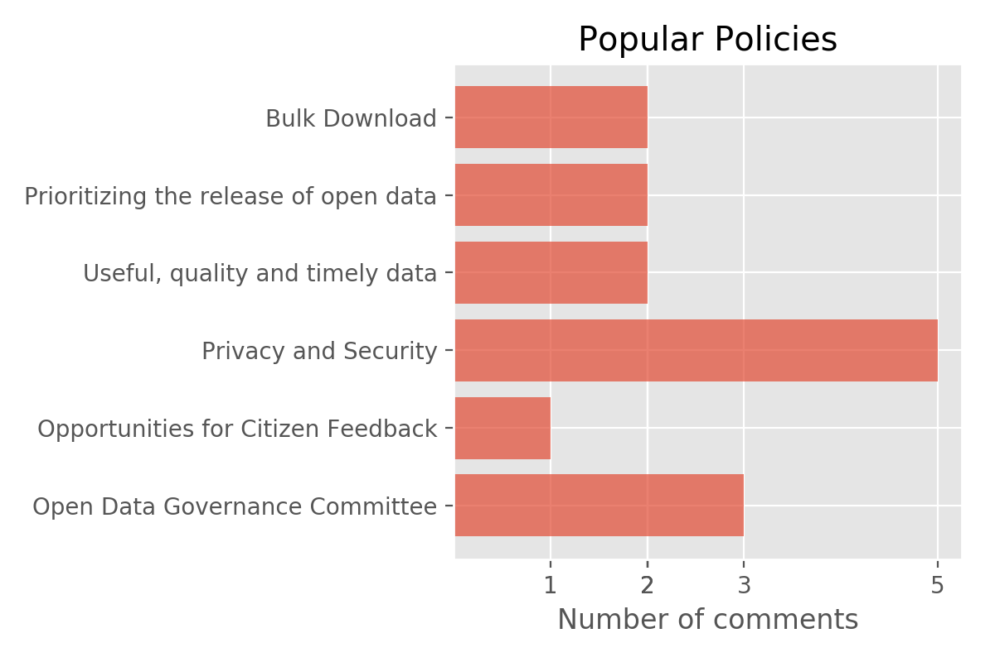

**~~Figure 2: Popular Policies~~**

Many people are talking about how open data can handle private and sensitive information **(City of Syracuse and City of Buffalo)**, and the role played by Open Data Governance Committees to invite feedback from and collaborate with residents **(City of Naperville).**

The comments also show that users are not only appreciating the policy but also encouraging additional changes where necessary. For example, in the following example, the user would like the dataset to be more interactive and customer-friendly, instead of only existing in a high quality format.



While the comments regarding opportunities for citizen feedback were few, they were highly liked or replied to by other people. Mark Headd, Innovation Specialist at 18F, commented on the City of Syracuse’s Open Data Policy that a board, comprising of public members and other stakeholders, should be established that will ensure residents are heard and valued.

We consider comments to be “popular” if they have been ”liked” or “replied to” (by other people) three times or more. Comments were most popular in the cities of Buffalo, Naperville and Syracuse given the higher levels of community engagement in these cities.

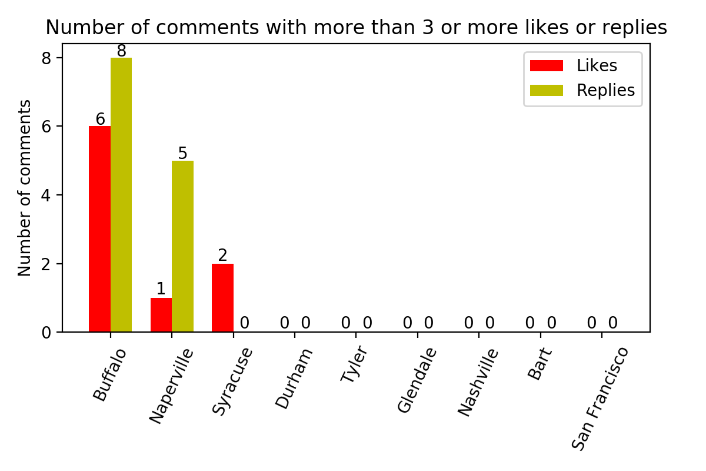

Some other highly liked or replied to comments were regarding tools to make data easily accessible and useful such as through creation of meta data **(Joseph Gosen, Buffalo)** or presenting it in a range of formats such as xml, shapefile etc. **(Karyn Tareen, CEO, Geocove - Buffalo).**

**~~Figure 3: City-wise number of comments that received three or more likes/replies~~**

Involving citizens in the process of releasing data sets seems to be the most important concern. This can take place through better ways to engage with citizens online or formally represent them on the committee of people who make open data policies. Residents, especially with a little know how about different formats of data sets, want datasets to be interactive and useful. Ideally, cities should equip residents with data literacy tools so that they can derive value from open data.

***User reaction to open data policy sections***

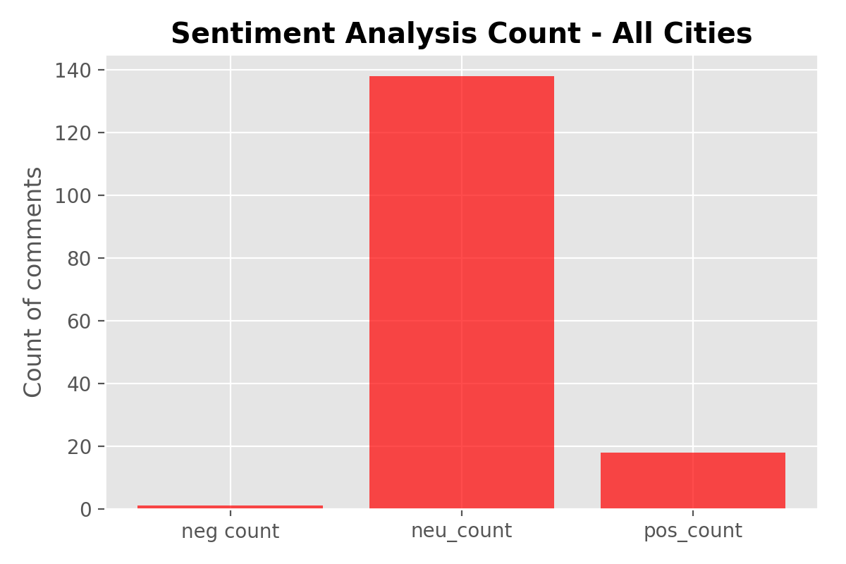

-total comments: 164

-talk about most positive issues (make two lists: issues and count for all cities combined)

-most negative issues

-and some neutral questions - why it’s a good thing that users are curious

**Understanding the user segments of open data can help cities expand their open data reach**

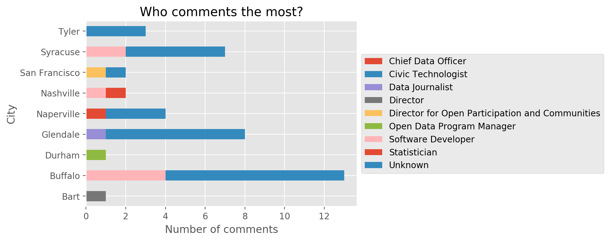

**Figure 4: Who comments the most?**